Project Goal
The goal of this graded project is to create the following financial statements for J & L Accounting, Inc.:
- Balance sheet
- Income statement
- Statement of retained earnings
- Post-closing trial balance
The financial statements must be created in one Microsoft Word document (.doc or .docx file). Alternatively, an Excel workbook may be used (.xls or .xlsx file). The Word or Excel file will be uploaded for grading.

Instructions
Read the following instructions thoroughly before beginning your work to get familiar with the project. Students who start on the project right away, thinking they’ll save time, tend to get stuck and spend more time working through the project than is necessary. The material you need to know in order to complete the project has been covered in the textbook and the assigned exercises. If you understand the chapters and completed the assigned homework problems, you should have no problem with the project.
The project is to be done by hand with a pencil and paper, using the blank forms provided. At the end of the project are instructions for creating and uploading the financial statements in a Word or Excel file for grading.
Note: The formatting of financial statements is important. They follow Generally Accepted Accounting Principles (GAAP), which creates a uniformity of financial statements for analyzing. This allows for an easier comparison, as all businesses follow GAAP. The financial statements should be created exactly as shown or described in the textbook. Incorrect formatting will result in a loss of points.
Debits equal credits is a fundamental principle of accounting that must not be violated. Debits not equaling credits allows for “cooking the books,” which means presenting false information. It also allows for embezzlement, which is theft by management or employees. If debits don’t equal credits, the cause may be a lack of understanding of accounting principles or a lack of focus and concentration when making journal entries, posting to ledger accounts, or completing math. Remember—instructors are available to help you with material you may be struggling with.
Mistakes are best corrected by going back over the work until the error is found. The accounting equation must balance on the balance sheet. This is another fundamental principle of accounting that can’t be violated. When the equation doesn’t balance and the numbers are “fudged,” this is easily detectable by someone who knows accounting. If your debits equal your credits and you understand which general ledger accounts belong on which financial statements, then the accounting equation should balance.
The following financial statements are provided from the prior accounting period for J & L Accounting, Inc.:
- Post-closing trial balance
- Balance sheet
- Income statement
- Statement of retained earnings
J & L Accounting, Inc.
Post-Closing Trial Balance
December 31, 2017
 | Balance
Account Title | Debit | Credit
Cash, Business Checking | $20,500.00
Accounts Receivable Prepaid Rent Vehicles | 48,000.00
Accumulated Depreciation, Vehicles |  | $12,000.00
Equipment | 3,600.00
Accumulated Depreciation, Equipment |  | 600.00
Accounts Payable Common Stock |  | 38,000.00
Retained Earnings |  | 21,500.00
Dividends
Service Revenue
Advertising Expense
Rent Expense
Office Supplies Expense
Telephone Expense
Utilities Expense
Depreciation Expense
Totals | $72,100.00 | $72,100.00

J & L Accounting, Inc.
Balance Sheet
As of December 31, 2017
Assets
Cash, Business Checking |  | $20,500.00
Accounts Receivable |  | 0.00
Prepaid Rent |  | 0.00
Vehicles | $48,000.00
Less: Accumulated Depreciation, Vehicles | 12,000.00 | 36,000.00
Equipment | 3,600.00
Less: Accumulated Depreciation, Equipment | 600.00 | 3,000.00
Total Assets |  | $59,500.00
Liabilities
Accounts Payable |  | $0.00
Total Liabilities |  | $0.00
Stockholders' Equity
Common Stock |  | $38,000.00
Retained Earnings |  | 21,500.00
Total Stockholders' Equity |  | $59,500.00
Total Liabilities and Stockholders' Equity |  | $59,500.00

J & L Accounting, Inc.
Income Statement
For the Month Ending December 31, 2017
Revenues
Service Revenue |  | $10,275.00
Expenses
Advertising Expense | $2,300.00
Rent Expense | 1,000.00
Office Supplies Expeses | 300.00
Telephone Expense | 750.00
Utilities Expense | 3,200.00
Total Expenses |  | 8,650.00
Net Income |  | $1,625.00

J & L Accounting, Inc.
Statement of Retained Earnings
For the Month Ending December 31, 2017
Retained Earnings December 1, 2017 | $19,875.00
Add: Net Income | 1,625.00
Subtotal | 21,500.00
Less: Dividends | 0.00
Retained Earnings, December 31, 2017 | $21,500.00
- Using Form A from the graded project forms you downloaded (make as many copies as necessary), set up the accounts for the general ledger and insert the beginning balances for the accounts from the post-closing trial balance. The balances from the post-closing trial balance become the beginning balances of the accounts for the next account period.
cash-business checking
date | item | post ref | debit | credit | balance
 |  |  |  |  | debit | credit
1-Jan |  |  |  |  | 20500
Vehicles
date | item | post ref | debit | credit | balance
 |  |  |  |  | debit | credit
1-Jan |  |  |  |  | 48000
Accumulated depreciation- vehicles
date | item | post ref | debit | credit | balance
 |  |  |  |  | debit | credit
1-Jan |  |  |  |  |  | 12000
Equipment
date | item | post ref | debit | credit | balance
 |  |  |  |  | debit | credit
1-Jan |  |  |  |  | 3600
Accumulated depreciation- equipment
date | item | post ref | debit | credit | balance
 |  |  |  |  | debit | credit
1-Jan |  |  |  |  |  | 600
common stock
date | item | post ref | debit | credit | balance
 |  |  |  |  | debit | credit
1-Jan |  |  |  |  |  | 38000
retained earning
date | item | post ref | debit | credit | balance
 |  |  |  |  | debit | credit
1-Jan |  |  |  |  |  | 21500

2. Journalize the following transactions in the general journal using Form B from the graded project forms you downloaded (make as many copies as needed). Each journal entry’s debits should equal its credits. This is a fundamental GAAP that can’t be violated. (A journal entry error, such as posting $1,010 instead of $1,100, can be corrected at the adjusting/correcting journal entries step.)
- On January 1, 2018, a payment in cash for $12,000 is made for prepaying rent for the entire year 2018.
- On January 4, 2018, accounting services are performed and payment is received in cash for the amount of $1,900.
- On January 9, 2018, a payment in cash for advertising is made in the amount of $850.
- On January 10, 2018, office supplies are purchased in the amount of $75 with cash.
- On January 14, 2018, accounting services are performed and payment is received in cash for the amount of $2,725.
- On January 20, 2018, the telephone bill for the amount of $660 is received and paid with cash.
- On January 20, 2018, the utility bill for $2,925 is received. The bill won’t be paid until it’s due on February 15, 2018.
- On January 27, 2018, accounting services are performed on account in the amount of $3,750.
- On January 28, 2018, a payment in cash for $1,500 is made for a bill from an advertising agency.

date | account | debit | credit
1-Jan-18 | prepaid rent | $ 12,000
 | cash |  | $ 12,000
 | (to record rent payment for the year 2018)
4-Jan-18 | cash | $ 1,900
 | service revenue |  | $ 1,900
 | to record service revenue
9-Jan-18 | advertising expense | $ 850
 | cash |  | $ 850
 | to record advertising expense
10-Jan-18 | office supplies | $ 75
 | cash |  | $ 75
 | to record purchase of office supplies
14-Jan-18 | cash | $ 2,725
 | service revenue |  | $ 2,725
 | to record service revenue
20-Jan-18 | telephone expense | $ 660
 | cash |  | $ 660
 | to record telephone expense
20-Jan-18 | utilities expense | $ 2,925
 | accounts payable |  | $ 2,925
 | to record utilities expense
27-Jan-18 | accounts receivable | $ 3,750
 | service revenue |  | $ 3,750
 | to record service revenue
28-Jan-18 | advertising expense | $ 1,500
 | cash |  | $ 1,500
 | to record advertising expense

3. Post the general journal entries from the journal to the corresponding general ledger accounts, paying particular attention to whether they’re debits or credits. Use the Post Ref. column to ensure that each line item of the journal entries is posted correctly to each general ledger account. Posting from the journal to the general ledger is simply rearranging the information. If the debits equal the credits for a particular journal entry and the information is posted correctly, the total of the debits should equal the total of the credits in the general ledger.

4. Calculate the balances in the general ledger accounts, running the numbers several times for accuracy. Often, debits won’t equal credits on the trial balance because a hand-held calculator is used and the math is done only once. Using a hand-held calculator can introduce errors. This is why an Excel spreadsheet is recommended. However, if a hand-held calculator is all that’s available to you, be sure to do the math enough times that you know the calculations are accurate. To calculate the balances in the ledger accounts, do the following:
- Add the debits.
- Add the credits.
- Subtract the larger amount from the other, or, alternatively, keep the running balance of the amount in the account and whether it’s a debit or credit on the ledger.
5. Create an unadjusted trial balance from the balances in the general ledger accounts. If the debit and credit columns are unequal, an error has been made and must be found and corrected. See Section 1.3 for an example of an unadjusted trial balance. Use Form C from the Graded Project Forms you downloaded.

6. Journalize the following adjusting journal entries in the general journal, being sure that the debits equal the credits:
- Calculate and make the adjustment for the amount of prepaid rent that has been used.
- Make an adjusting journal entry in the amount of $1,000 for depreciation of the vehicles.
- Make an adjusting journal entry in the amount of $100 for depreciation of the equipment.

Prepaid rent balance at the end of first month (12000-1000) |  |  | $ 11,000
Event | Account title & explanation | Debit | Credit
A | Rent expense | 1,000
 | Prepaid rent |  | 1,000
 | (To record rent expense for the month.)
B | Depreciation expense | 1,000
 | Accumulated depreciation - vehicles |  | 1,000
 | (To record depreciation expense - vehicles.)
C | Depreciation expense | 100
 | Accumulated depreciation - equipment |  | 100
 | (To record depreciation expense - equipment.)

7. Post the adjusting journal entries to the respective general ledger accounts, again being sure that the postings are to the correct debit or credit side and using the Post Ref. column.
prepaid rent |  |  | balance
particulars | debit | credit | debit | credit
cash | 12000 |  | 12000

service revenue |  |  | balance
particulars | debit | credit | debit | credit
cash |  | 1900 | 12000 | 1900
cash |  | 2725 |  | 4625
acounts receivable |  | 3750 |  | 8375

advertsing expense |  |  | balance
particulars | debit | credit | debit | credit
cash | 850 |  | 850
cash | 1500 |  | 2350

office supplies |  |  | balance
particulars | debit | credit | debit | credit
cash | 75 |  | 75

telephone expense |  |  | balance
particulars | debit | credit | debit | credit
cash | 660 |  | 660

utilities |  |  | balance
particulars | debit | credit | debit | credit
utilities payables | 2925 |  | 2925

utilities |  |  | balance
particulars | debit | credit | debit | credit
utilities |  | 2925 |  | 2925

accounts receivable |  |  | balance
particulars | debit | credit | debit | credit
service revenue | 3750 |  | 3750

8. Calculate the new balances in the general ledger accounts. Create an adjusted trial balance from the balances in the general ledger accounts using another copy of the form used to create the unadjusted trial balance. See Exhibit 3-3 in your textbook for an example of an adjusted trial balance. Make sure the math is correct and that the debit column is equal to the credit column. If not, don’t continue until the error has been found.

adjusted trial balance
particulars
cash | 10460
prepaid rent | 12000
service revenue |  | 8375
advertising expense | 2350
office supplies | 75
telephone expense | 660
utilities payable |  | 2925
utilities payable | 2925
account receiable | 3750
capital(bal) |  | 20920
totals | 32220 | 32220

9. Create the income statement for J & L Accounting, Inc. using the information from the adjusted trial balance. Use Form D from the Graded Project Forms you downloaded to create the income statement. Its format should be the same as that of the statement provided at the beginning of the project for the prior accounting period.
10. Create the closing journal entries in the general journal to close the revenue, expense, and dividend accounts to the retained earnings account, paying attention to debits equaling credits.
11. Post the closing journal entries to the respective general ledger accounts.
12. Calculate the balances in the general ledger accounts.
13. Create a post-closing trial balance from the balances in the general ledger accounts using the same blank form as used for the unadjusted trial balance. Your post-closing trial balance should be in the same format as the post-closing trial balance provided at the beginning of the project for the prior accounting period. Make sure the math is correct and that the debit column is equal to the credit column. If not, don’t continue until the error has been found.
14. Create the balance sheet for J & L Accounting, Inc. using the information from the post-closing trial balance. If the debits equal the credits from the previous work and the closing entries were made properly, then the accounting equation should balance on the balance sheet. If the assets don’t equal the liabilities plus stockholders’ equity, an error has been made that needs to be corrected. The balance of the accounting equation is another fundamental GAAP principle that can’t be violated. Use Form D from the Graded Project Forms you downloaded to create the balance sheet. Its format should be the same as that of the statement provided at the beginning of the project.
15. Create the statement of retained earnings for J & L Accounting, Inc. using the ending balance from the statement of retained earnings from the prior period and the net income from the income statement for the January accounting period. (No dividends were paid out during the month of January.) Follow the same format from the statement of retained earnings at the beginning of the graded project for the prior accounting period using the blank form that follows. Use Form E from the Graded Project Forms you downloaded.
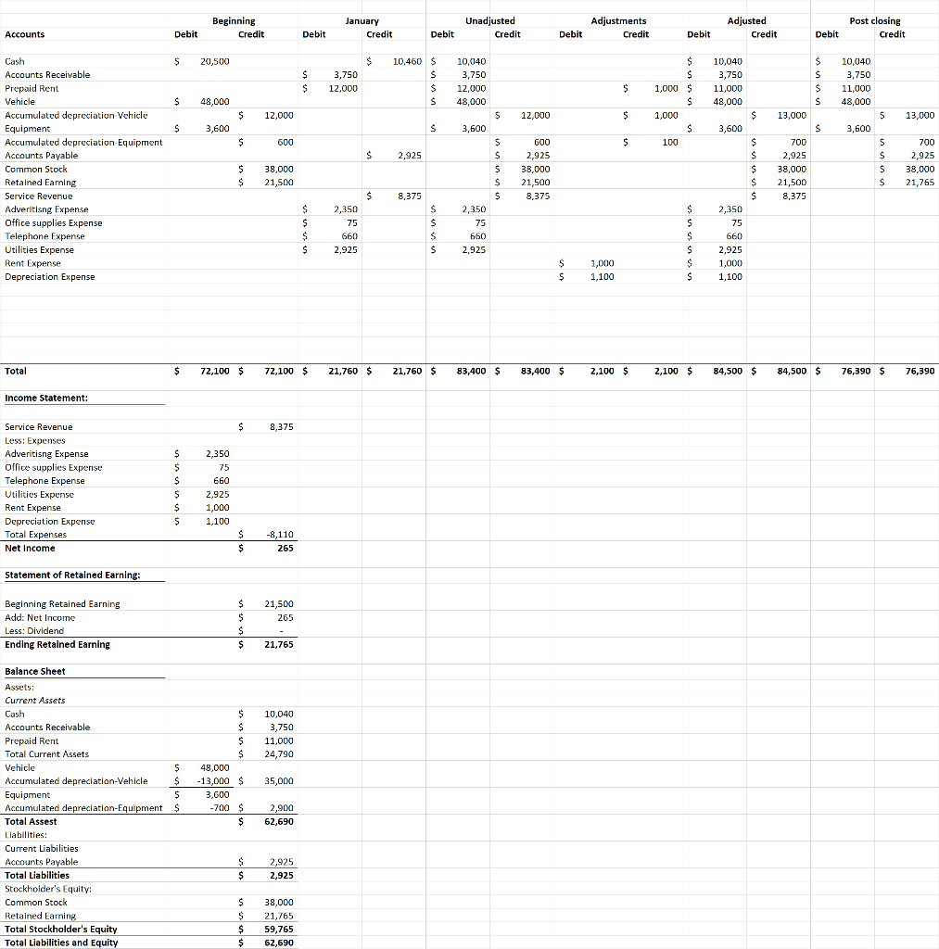

Preparing Statements for Submission
Having created the balance sheet, the income statement, the statement of retained earnings, and the post-closing trial balance on the blank forms that were provided, the financial statements must now be typed up in a Microsoft Word document and saved as a .doc or .docx file. Microsoft Excel can also be used (saving the file with the extension .xls or .xlsx).
Each financial statement should be on its own page (or worksheet). The name of the file should include your student ID number and the graded project exam number, such as “21512345_061468.docx” as an example.
Insert tables in the Word document if you feel you need them to format the financial statements. Alternatively, space and tab in Word to get the formatting of the statements set up correctly.
Formatting is important. Points will be deducted for incorrect capitalization, spelling, underlining and double underlining, as well as for improper headings, dates, indentations, and columns.
Create all of the financial statements in one file. This is important for tracking and grading purposes. Submission of more than one file will result in the project being returned as ungraded.
Images or scanned images of the financial statements pasted into a Word document will also be returned ungraded. These files can’t be “marked up,” and handwritten financial statements are generally considered unprofessional.
Only the financial statements are required. Submitted journals, ledgers, or unadjusted/adjusted trial balances won’t be evaluated.

Plagiarism
Plagiarism is taking any part of a published piece of work and using it as your own and is unacceptable at Penn Foster College. As explained in your Student Handbook, students are expected to conduct themselves with the highest academic and ethical standards. Failure to do so results in disciplinary action.

Grading Criteria
The grading criteria for the project are as follows:
Formatting: The formatting of the four financial statements is worth 10 points each for a total of 40 points (4 x 10 = 40).
- An out-of-balance accounting equation on the balance sheet will result in a loss of 10 points for the of the balance sheet even though other formatting issues may be correct.
- Debits not equaling credits on the post-closing trial balance will result in a loss of 10 points for formatting of the post-closing trial balance even though other formatting issues may be correct.
- Not having made closing journal entries as reflected on the post-closing trial balance will result in a loss of 10 points for formatting of the post-closing trial balance even though other formatting issues may be correct.
Figures: Calculations on the financial statements are based on 18 balances from the general ledger accounts. The beginning retained earnings balance on the statement of retained earnings, and the correct ending retained earnings balance on the statement of retained earnings, are also included. This amounts to a total of 20 figures. Each is worth 3 points for a total of 60 points (20 x 3 = 60).
Thus, the formatting of the financial statements (worth 40 points total) plus the figures used for the financial statements (worth 60 points total) provide 100 points for the project.
If a project receives a failing grade (less than 70 points), the project will have to be reworked and resubmitted for final grading. The highest grade that can be obtained on a retake is 70, which is passing.

